SCMS School of Engineering and Technology
Department of MCA
Project Planning & Proposal Form

Project Title : ARM
Name : JOEL JOJU
Roll No : 20
Class : S4 MCA
Date : 20/01/2025

1. Purpose of project
The purpose of "ARM" is to develop a gesture-controlled robotic arm that demonstrates the integration of machine learning, computer vision, and hardware systems to perform precise and intuitive object handling tasks. It aims to explore innovative human-machine interaction methods, providing insights for applications in automation, education, and assistive technologies.

2. Project Outline
The "ARM" project focuses on developing a gesture-controlled robotic arm that combines computer vision, robotics, and machine learning for intuitive operation. Using hardware components such as Arduino Uno R3, MG90 servos, PCA9685 servo driver, a voltage regulator, and a 12V adapter, the system interprets hand gestures captured via a camera using Mediapipe for gesture recognition. The processed gestures are transmitted to the Arduino through Python-based serial communication to control the robotic arm's movements. The project leverages technologies like OpenCV, Mediapipe, and PySerial to achieve precise and responsive actions, enabling applications in automation, education, and assistive technologies.

3. Project outcomes/key deliverables
- A robust system using Mediapipe and OpenCV for real-time hand gesture detection and interpretation.
- Accurate control of the robotic arm’s claw, base rotation, and lifting mechanisms using Python and Arduino-based serial communication.
- Successful integration of Arduino Uno R3, MG90 servos, PCA9685 servo driver, and power regulation components for reliable operation.
- A system demonstrating potential uses in automation, education, and assistive technologies.

- Resource Assessment
Proposed Budget
The proposed budget for the project includes the following key hardware components:
- Arduino UNO R3 : ₹2,500
- Arduino USB cable : ₹110
- MG90S servo motor : ₹246 x 4 = ₹984
- PCA9685 Servo motor driver : ₹588
- 5v voltage regulator : ₹160 (estimated)
- 12v DC power adapter : ₹699
- Jumper wires : ₹179
- 3D printed robotic arm : ₹1800 (estimated)
The total estimated project cost is ₹7020. Also some additional expenses arise for assembly materials such as screws, nuts, cleaning supplies for the 3D-printed arm model.
Technology Used
Hardware:
- Arduino UNO R3
- MG90S servo motors
- PCA9685 Servo motor driver
- 5v voltage regulator
- Web camera(Laptop)
Software:
- Arduino IDE
- Python and its required libraries- OpenCV, PySerial and MediaPipe

- Timeline with Milestones Gantt charts

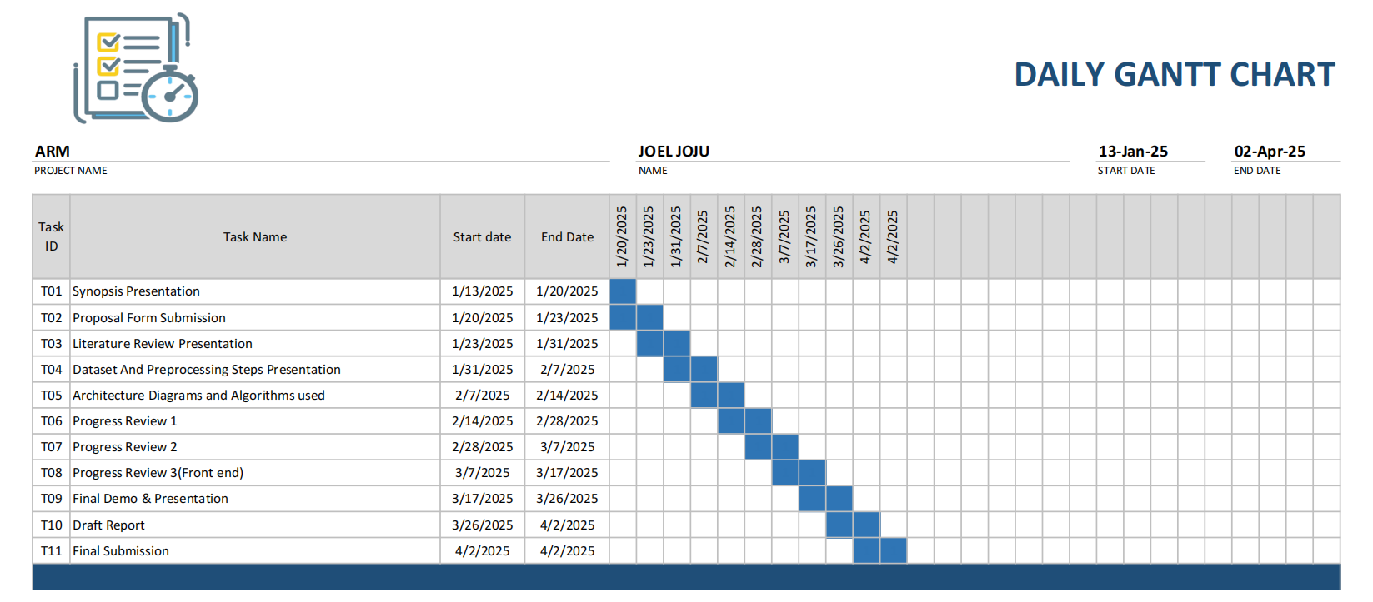

Approved by

Project guide | Project Coordinator
Asst.Prof. DONEY DANIEL | Asst.Prof. GRESHMA P SEBASTIAN
Dept of CSE | Dept of CSE

